**Objective:**

To develop a user-friendly dashboard that visually presents information and data in a clear, organized manner. The dashboard will serve as a real-time monitoring and analysis tool, tailored to a specific use case or operational need. It will be designed to support decision-making by displaying key performance indicators (KPIs), performance metrics, and critical data using visual elements such as charts, graphs, and tables. The dashboard will be applicable across various industries, including business, finance, manufacturing, and healthcare, ensuring flexibility and relevance for diverse operational environments**.**

.**Process followed:**

**Process for Creating the "Strategic Product Placement Analysis" Dashboard:**

1. **Requirement Gathering:**  
   Identify the key goals, metrics, and data sources needed for strategic product placement.
2. **Data Collection:**  
   Gather relevant data from internal and external sources (e.g., sales data, customer behavior, market trends).
3. **Data Cleaning & Preparation:**  
   Clean, organize, and structure the data to ensure accuracy and consistency.
4. **Dashboard Design:**  
   Plan the layout, choose visual elements (charts, graphs, tables), and ensure the design aligns with user needs.
5. **Development:**  
   Build the dashboard using appropriate tools (e.g., Power BI, Tableau, Excel, etc.), integrating real-time data where needed.
6. **Testing & Review:**  
   Test the dashboard for functionality, accuracy, and usability. Make adjustments based on user feedback.
7. **Deployment:**  
   Launch the dashboard for stakeholders, ensuring access permissions and proper documentation are in place.
8. **Monitoring & Updates:**  
   Regularly update the dashboard with new data and improve features as needed.

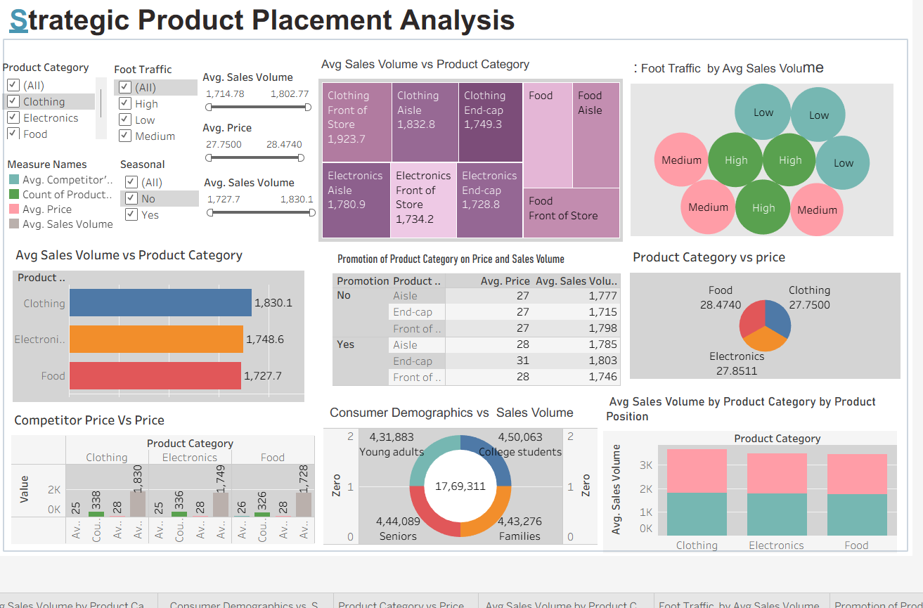

**The dashboard provides a clear overview of:**

This dashboard provides a detailed multifactor analysis of how product category, placement, pricing, promotion, foot traffic, and demographics affect sales volume.

Key Takeaway: Placing products like Clothing and Food in high foot traffic and front locations, with promotions, maximizes sales performance.